Abstract

[Draw your reader in with an engaging abstract. It is typically a short summary of the document.   
When you’re ready to add your content, just click here and start typing.]

GAME NAME  
Cross Platform Development

Author: Ryan Lawrence

# Change Log

Updates made to the document should be described below.

|  |  |  |  |
| --- | --- | --- | --- |
| Version | Author | Date of change | Description |
| 0.0.0 | AIE | 31/08/2020 | Initial Template created |
| 0.1.0 | Ryan | 04/09/2020 | Filled in templated fields with limited info |
| 0.2.0 | Ryan | 09/09/2020 | Fleshed out some provided info |
|  |  |  |  |
|  |  |  |  |
|  |  |  |  |
|  |  |  |  |

Contents

Change Log 1

1.0 Development Environment 3

1.1 Game Engine 3

1.2 Source Control 3

1.3 Third-Party Libraries / assets 3

2.0 Game Overview 3

2.1 Genre 3

2.2 Camera Perspective and Movement 3

2.3 Platform 3

2.4 Technical Goals 4

2.5 Game Objects and Logic 4

3.0 Controls 4

3.1 Windows / Web 4

3.2 Console / Xbox 4

3.1 Android / Touch 4

4.0 Mechanics 4

5.0 Graphics 5

6.0 Audio 5

7.0 Artificial Intelligence 5

8.0 Game Flow 5

8.1 ‘Mission’ / ‘Level’ structure 5

8.2 Objectives/Goal 5

11.0 Interface 5

11.1 Menu 5

11.2 High scores 5

11.3 UI/HUD 5

12.0 Progress report and feedback Meeting Minutes 6

Friday 4th September 6

Wednesday 9th September 6

Thursday 10th September 6

Friday 11th September 7

# Development Environment

## Game Engine

Proprietary/Unreal/Unity and version engine version number, provide reason for choice

## Source Control

Link to github repo: <insert link here>

## Third-Party Libraries / assets

<State and explain the reason of use for any third-party libraries, assets from engine specific market places (Approval will be required) or packages.  
**All chosen third party libraries must be reviewed before adding to project by supervising teacher and licenses must be checked**>

|  |  |  |
| --- | --- | --- |
| Asset Name  License | Url | Reason for use |
| **Example:**  **Character Pack: Free Sample** Free –Unity Extension Asset | <https://assetstore.unity.com/packages/3d/characters/humanoids/character-pack-free-sample-79870> | Character asset use for main player in game. |
|  |  |  |
|  |  |  |
|  |  |  |
|  |  |  |
|  |  |  |

# Game Overview

Describe

Nova is a 2D linear platformer, the player will go through one large world instead of being level based. The main aim of the game is to navigate the caves and come out the over end.

## Genre

2D platformer, Side view, Linear.

## Camera Perspective and Movement

The camera will lerp to the players position.

## Platform

PC – The intended platform of the game, no extra requirements are needed to deploy to PC.

Mobile – On Screen controls (Left and right arrow and jump).

PC, VR, Mobile, etc. what are the requirements for deployment to each platform.   
Setup process has been outlined and detailed >

## Technical Goals

## Game Objects and Logic

Player – The player, user controlled.

Lava Boost Platform – Boosts the player with a high jump.

Fireball – Boosts the player with a high jump, Moves along a path.

Water Droplet – A drop of water that falls towards the ground, hurts the player

Water Droplet spawner – spawns water droplets on a timer.

# Controls

State the proposed control scheme for each platform

## 3.1 Windows / Web

Keyboard and gamepad:

Arrow keys / D-Pad / Left Stick, Horizontal movement.

Z key / A Button, Jumping

R Key / Select, Respawn

## 3.2 Console / Xbox

Gamepad:

D-Pad / Left Stick, Horizontal movement.

A Button, Jumping

Select, Respawn

## 3.1 Android / Touch

Touch controls.

Left and right arrow, Horizontal movement

Up Arrow Jump

Respawn Button, respawn/

# Mechanics

A list of intended core game mechanics. I.e., what the player can do and how they achieve this, and what this will trigger in the game. For example, shooting enemies is a core mechanic in an FPS.

* **Fire Boosting**Since the player is a fire elemental, when they make contact with fire they are boosted high into the air.

## Hazards

Water droplets, other water AGHASDHASDH Add here later

## Obstacles

UMMMMMMMMM

## Items / Collectables

There’re no real collectables in the game. I guess I can put the Save Points here.

# Graphics

Side view 2D. Post processing wise I’m using some vignettes some color correction and some bloom. Art style is pixel art, this was decided so I can make my own assets instead of using ones of the asset store. Anti-aliasing is disabled.

# Audio

Describe audio requirements. Sounds Effects, Ambient music etc

# Artificial Intelligence

Describe how your AI will works, i.e. state machine, fuzzy logic, GOAP. Describe the various behaviors

# Game Flow

## ‘Mission’ / ‘Level’ structure

The game, while having sperate scenes isn’t in “level” structure as in, it’s not clearly defined when an area is completed there’s no level complete screen or anything, this was done to make the world feel more connected as opposed to moving from area to area autonomously.

## Objectives/Goal

The goals to move through the cave and eventually reach the end. A smaller objective would be reaching the next save point.

1. Levels

Levels are built using a tile map and the tile map collider component, using tile rules generated by tilesetter a program that automates making tiles sets with 2 user defined sprites.

1. Items

N/A

# Interface

## Menu

New Game starts a game at the intended starting area.

Continue, loads game at the last save point

Exit, exits game, not in mobile and console versions.

Menus can be navigated through using mouse, keyboard and controller.

Buttons can be clicked, or navigated using keyboard or gamepad.

## UI/HUD

What is involved in the UI/HUB, what information is being provided to the player. Mock up of intended UI/HUD design

Main Menu

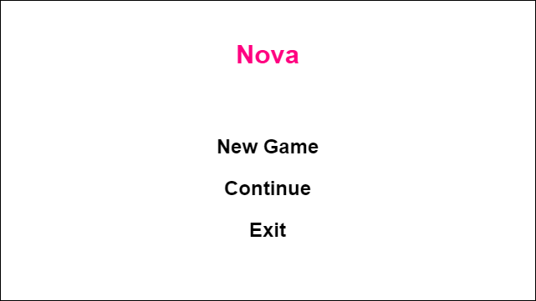

Gameplay



Gameplay Mobile

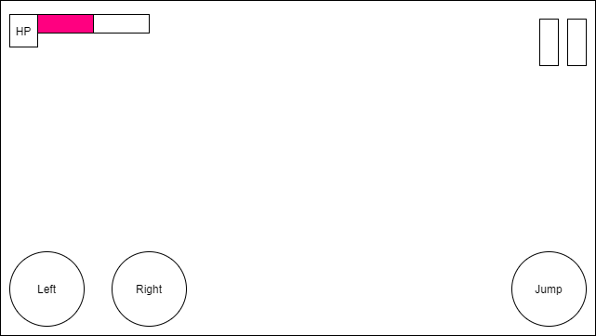

# Progress report and feedback Meeting Minutes

## Wednesday 9th September

Describe state of project

* Fireball, MoveEntityAlongPlath( and editor), HurtPlayerOnTouch components (scripts)
* Fireball sprite, emission map, animation.
* Fireball prefab
* FireballFollowPath prefab variant

Feedback from teacher and peers:

* Change camera to show fire jumping.

## Thursday 10th September

Describe state of project

* Main Menu Actions Thing
* Hp bar
* Player can die
* 2D lights

Feedback from teacher and peers:

* Add Lights
* Add Tutorial
* Fix a visual bug on tiles

Action Items:

* Describe
* Describe
* Describe

## Friday 11th September

Describe what has been done since last time

* Changed some lighting settings
* Tutorial screen only appears on pc
* Change lighting settings.
* Added comments and tooltips to most scripts.

Feedback from teacher and peers:

* Describe
* Describe
* Describe

Action Items:

* Describe
* Describe
* Describe